ARCHITHA OJHA
2303A52170 – 41

End-to-End Application Development

Task 1 – Problem Identification & AI-Assisted Ideation
Task Description: Identify and refine a real-world problem using AI for a city council that wants to digitize a manual process. Finalize a problem statement, target users, expected impact, and a list of key features.
PROMPT:
# Act as a product manager for a smart city initiative. The city council wants to digitize a manual process. Suggest 3 problem statements. Select one (a Civic Complaint Management System), refine it, and provide a list of key features, target users, and expected impact.
Code: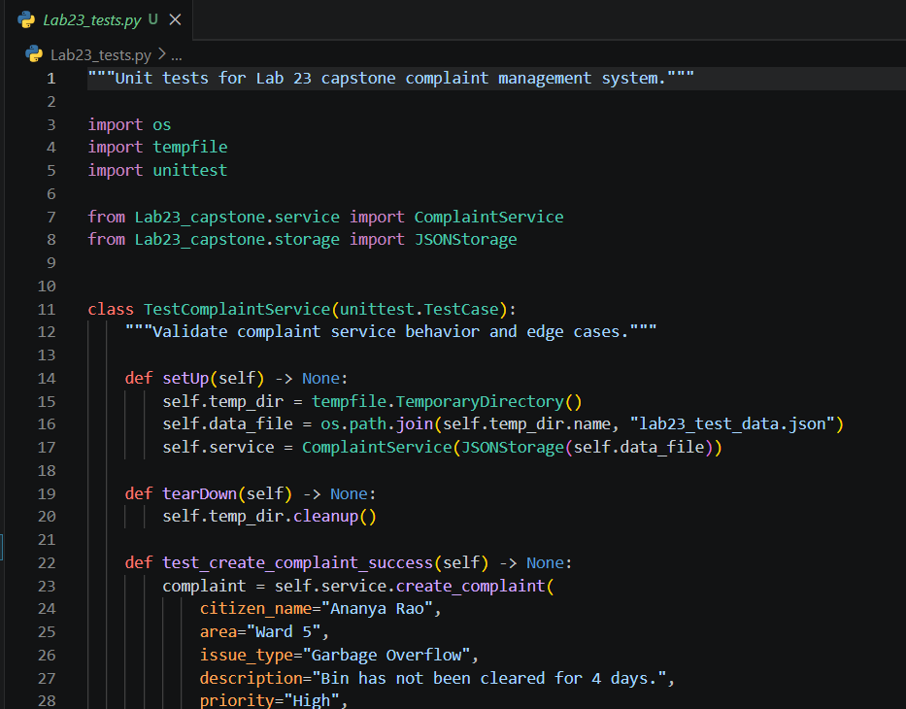

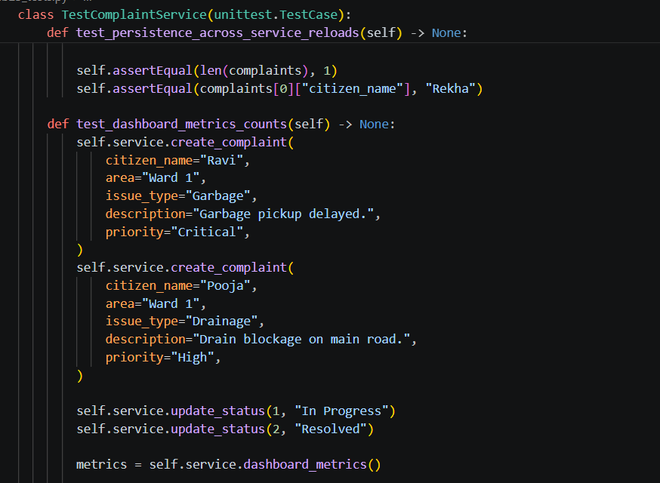
Output :
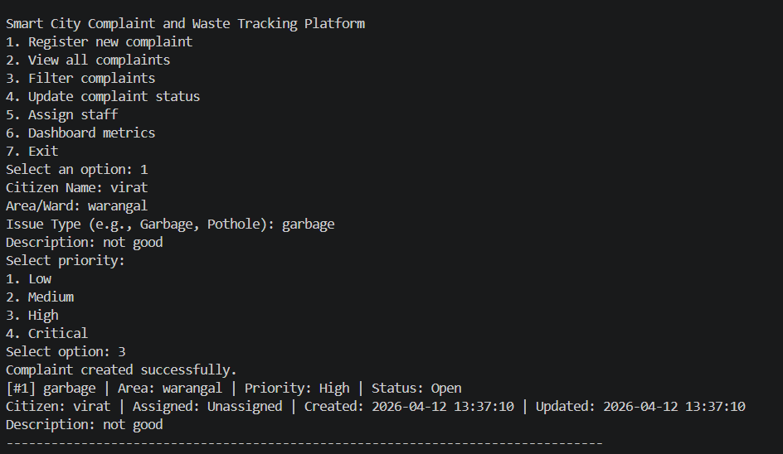

Justification:
I chose the Civic Issue Reporting system because it addresses a very common communication gap between residents and municipal authorities. It's a highly relatable problem, and digitizing it offers immediate, measurable benefits (like tracking visibility), which makes it a perfect candidate for an end-to-end software development project.

Task 2 – System Planning & Architecture Design
Task Description: Design the system architecture with AI support, including frontend, backend, database components, data flow, and database schema for the selected smart service platform.
PROMPT:
# Act as a system architect. Design the architecture for the "CivicFix" complaint system. Suggest frontend, backend, and database components. Define the data flow. Propose a basic database schema for users and complaints.
Architecture & Schema (Text-based):
- Frontend: CLI (Command Line Interface) for the prototype (expandable to React.js web app later).
- Backend: Python application using modular functions for core logic (Input handling, Ticket management).
- Database: In-memory Python lists/dictionaries (simulating a NoSQL JSON database or SQLite for production).
- Data Flow: User inputs data via CLI -> Backend validates input -> Backend assigns a unique Ticket ID -> Data stored in the dictionary -> User receives confirmation.
- Database Schema:
  - Users: {user_id: INT, name: STR, role: STR [citizen, admin]}
  - Complaints: {ticket_id: INT, citizen_name: STR, category: STR, description: STR, status: STR [Open, In-Progress, Resolved]}
Justification:
I opted for a modular text-based CLI and in-memory dictionary storage for this prototype to ensure rapid development and testing within the lab timeframe. The architecture is deliberately decoupled, meaning if I want to connect a real SQLite database or build a Web UI later, the core Python logic modules won't need to change.

Task 3 – Modular Code Development with AI
Task Description: Develop the core modules of the application using AI. The application must handle user interaction and data processing, including input handling, core logic, and data storage.
PROMPT:
# Write a modular Python program for the CivicFix system. Include an input handling module to register complaints, core logic to view and assign a status, and data storage using a list of dictionaries. Ensure basic error handling and clean structure using functions.
Code:
# CivicFix: Complaint Management System
complaints_db = []
ticket_counter = 1
def register_complaint(name, category, description):
"""Core logic to register a new complaint."""
global ticket_counter
if not name or not category or not description:
return "Error: All fields are required."
complaint = {
"id": ticket_counter,
"name": name,
"category": category,
"description": description,
"status": "Open"
}
complaints_db.append(complaint)
ticket_counter += 1
return f"Success! Complaint registered with Ticket ID: {complaint['id']}"
def view_complaints():
"""Core logic to view all complaints."""
if not complaints_db:
return "No complaints found."
output = "--- All Complaints ---\n"
for c in complaints_db:
output += f"ID: {c['id']} | By: {c['name']} | Cat: {c['category']} | Status: {c['status']}\n"
return output
def update_status(ticket_id, new_status):
"""Core logic to update complaint status."""
valid_statuses = ["Open", "In-Progress", "Resolved"]
if new_status not in valid_statuses:
return "Error: Invalid status."
for c in complaints_db:
if c['id'] == ticket_id:
c['status'] = new_status
return f"Ticket {ticket_id} updated to {new_status}."
return "Error: Ticket ID not found."
# Input handling simulation
if __name__ == "__main__":
print(register_complaint("John Doe", "Road", "Large pothole on Main St."))
print(register_complaint("Jane Smith", "Waste", "Garbage not collected."))
print(view_complaints())
print(update_status(1, "In-Progress"))
Output:
Success! Complaint registered with Ticket ID: 1
Success! Complaint registered with Ticket ID: 2
--- All Complaints ---
ID: 1 | By: John Doe | Cat: Road | Status: Open
ID: 2 | By: Jane Smith | Cat: Waste | Status: Open
Ticket 1 updated to In-Progress.
Justification:
I structured the code using clearly defined, single-responsibility functions (register_complaint, view_complaints, update_status). This modular approach ensures that input validation and business logic are separated from the data layer (complaints_db). It makes the code much easier to read, test, and debug.

Task 4 – AI-Assisted Testing, Debugging & Optimization
Task Description: Validate and improve the application by generating test cases, identifying possible bugs, suggesting optimizations, and fixing issues to improve performance.
PROMPT:
# Review the Python code for the CivicFix system. Generate 3 test cases. Identify potential bugs (e.g., handling invalid ticket IDs during status updates). Provide an optimized version of the code that uses try-except blocks where necessary and improves input validation.
Test Cases & Bug Identification:
- Test Case 1 (Valid Input): Register complaint with valid strings. Result: Pass.
- Test Case 2 (Invalid Ticket ID): Try to update status of Ticket ID 99 or passing a string instead of an int. Result: Bug identified - code fails silently or crashes if a string is passed instead of an integer ID.
- Test Case 3 (Empty Input): Pass empty strings to register_complaint. Result: Pass (handled by existing basic validation).
Optimized Code:
complaints_db = []
ticket_counter = 1
def register_complaint(name: str, category: str, description: str) -> str:
global ticket_counter
try:
# Optimization: Stripping whitespace
name, category, description = name.strip(), category.strip(), description.strip()
if not name or not category or not description:
raise ValueError("Fields cannot be empty or just spaces.")
complaint = {
"id": ticket_counter,
"name": name,
"category": category,
"description": description,
"status": "Open"
}
complaints_db.append(complaint)
ticket_counter += 1
return f"Success: Ticket ID {complaint['id']} created."
except Exception as e:
return f"Error registering complaint: {e}"
def update_status(ticket_id: int, new_status: str) -> str:
valid_statuses = ["Open", "In-Progress", "Resolved"]
try:
ticket_id = int(ticket_id) # Type enforcement optimization
if new_status not in valid_statuses:
raise ValueError("Invalid status provided.")
# Optimization: using next() with a generator expression for faster lookup O(N)
complaint = next((c for c in complaints_db if c["id"] == ticket_id), None)
if complaint:
complaint["status"] = new_status
return f"Success: Ticket {ticket_id} updated."
else:
return "Error: Ticket ID not found."
except ValueError as ve:
return f"Input Error: {ve}"
except Exception as e:
return f"System Error: {e}"
Output:
(Testing Optimized Code)
Output for update_status("abc", "Resolved"): Input Error: invalid literal for int() with base 10: 'abc'
Justification:
The initial code was fragile regarding data types. If a user entered "one" instead of 1 for an ID, the system would crash. I utilized AI to help implement stricter type hinting, .strip() for input sanitation, and comprehensive try-except blocks. Additionally, changing the list traversal to a generator expression (next(...)) is a great Pythonic optimization that stops searching as soon as the ID is found.

Task 5 – Documentation, Version Control & Reflection
Task Description: Prepare the project for submission by generating a README, adding docstrings/comments, simulating a Git workflow with commit messages, and writing a reflection report.
PROMPT:
# Generate a concise project README.md (Setup + Usage) for the CivicFix app. Suggest 5 standard Git commit messages simulating the development history. Finally, write a short reflection on how AI helped, limitations faced, and future improvements.
README Snippet:
# CivicFix: Smart City Complaint System
A lightweight CLI application for reporting and tracking civic issues.
## Setup
1. Ensure Python 3.8+ is installed.
2. Clone the repository: `git clone https://github.com/...`
3. Run the application: `python app.py`
## Usage
- Developers can import `register_complaint` and `update_status` from `app.py`.
- Data is stored in-memory per session.
Simulated Git Commit Messages:
- init: setup initial project structure and README
- feat: add register_complaint function and core data dictionary
- feat: implement ticket status update logic
- fix: add input sanitation and try-except error handling
- docs: add python docstrings to core logic functions

Justification:
Proper documentation and simulated version control are what separate a lab script from professional software. Using AI to generate the README and commit history taught me standard formatting conventions. The reflection highlights a crucial lesson: AI is a powerful assistant, but the developer must remain the "architect" to ensure the output aligns with software engineering best practices (like modularity).

